JustHealth: Market Research and Design

# Naming

There are different factors to consider when choosing a name for an application; it needs to be eye catching, easy to remember and encapsulate the primary purpose.

The names put forward included ideas such as:

* eCare/e-care/e-carer
* HUKI (Healthy and you know it)
* eDoctor
* Medicare
* **JustHealth**
* JustCare
* SimpleCare
* EasyDoctor
* Take it easy
* Medicapp

The group united on JustHealth after discussing each idea.

# Logo and branding

There are presently over 31,000 applications on the market that fall into the health & fitness bracket; an industry that is estimated to be worth over $600 million. Although these are unregulated and can be giving misleading information, there is an obvious need to stand out from the market and be unique. Market research when attempting to design for your company has to be done slightly differently, it is very hard for the brain to differentiate from images you have already seen, which

Whilst researching branding, it was noticeable that there were a number of factors to take into account.

* Colours
* Fonts
* Pictures (Logo)
* Size
* Letter spacing
* Capitalisation

After a few hours with a sketchpad, discussing aesthetics of logos and designing an image to brand JustHealth with, we had an initial design to build from.



Figure : JustHealth Logo v1 (Compilation of ideas)

### Colours:

There are many elements of the logo that could be chosen to be coloured. However, after some market research, it became obvious that successful companies use a maximum of 3 colours. Google are one of the rare instances where more than 3 colours have been used and they have successfully gained worldwide recognition with those colours.

After experimenting with different colours, we have settled on an initial design involving variations of blue.

**Blue:** many healthcare companies use blue, so there is a lot of competition; positive association with the colour of hospital uniforms.

**Red:** common association with blood, not the primary focus of our application and want to avoid distraction from the purpose.

**Yellow:** difficult to find complimentary colours to fit with it, negative connotations with many illnesses.

**Green:**  ‘Go’, encouraging, positive connotations; negative in terms of illnesses.

We decided to keep black away from the logo as white text seemed to be slightly more distinctive on the dark blue background.

Version 1 RGB colours:

*Background: R 63, G 72, B 204*

*Font: R 255, G 255, B 255*

*Image: R 40, G 227, B 120*

### Font

We tried to keep a simplistic, Sans-serif font that would be both easy to replicate and eye catching. Version 1 uses ‘Miranda’.

### Capitalisation

When deciding on a name for our application, we came up with JustHealth, but when designing a logo, the format in which the word is written can define whether it is successful.

The decision will have to be taken whether to adapt from our original idea to one of the following:

* JustHealth
* Justhealth
* justhealth
* JUSTHEALTH

## - VERSION 2 HERE –

# Web-based application designs

## Login screen

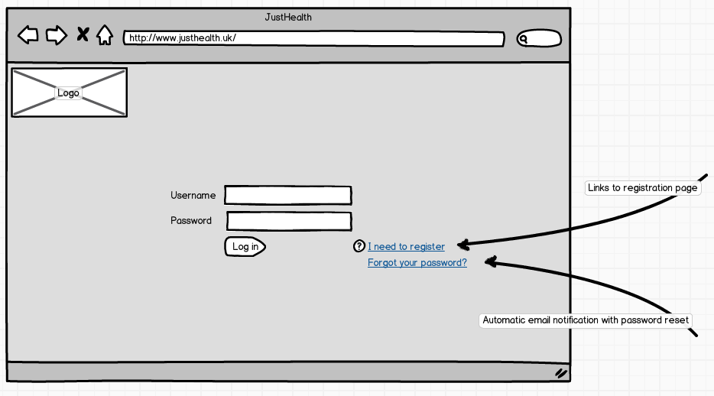

## Registration page

# Android application

## Login screen

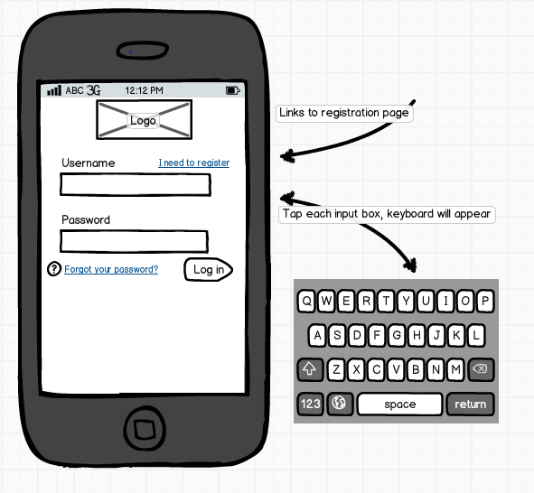

## Registration page

## 